The Metal-Oxide-Semiconductor Field-Effect

Transistor (MOSFET)

Suyeon Rhim, Arjun Behl, Pei Xian Yang

PCS 224-102 Liam Kischuck

## Introduction:

The objective of this experiment is to envision the IV characteristics for a MOSFET Transistor for different conditions of gate voltage and drain-source voltage and to also determine the threshold voltage and transconductance gain of the transistor.

## Theory:

Metal-Oxide-Semiconductor-Field-Effect Transistor is one of the major types of transistor. Usually MOSFET contains two n/p-doped regions(known as drain and source), embedded in a p/n type substrate .A MOS Capacitor plays a huge role in the behavior and operation of MOSFET. When gate voltage is 0 volts the Fermi energy level of metal and semiconductor align. When gate voltage is lesser than 0 volts the Fermi energy level of metal increases by qVG. This causes negative charge to deposit at the gate, which in turn causes holes to gather at the oxide-semiconductor interface. When Vg is greater than 0 causes positive charges to build up at the gate and as a result negative charges build up at the oxide-semiconductor interface. As gate voltage becomes very large, the semiconductor near the oxide space becomes inverted, becoming a n channel. The gate voltage required for this inversion is known as the threshold voltage.When gate voltage is less than the threshold voltage(VT), A voltage applied from drain to source(VDS) doesn’t induce a current in MOSFET, but when the gate voltage becomes larger than the threshold voltage current flows if a drain to source voltage is applied. The current is known as Drain current and can be expressed as:

ID = Kn[2( VG - VT)VDS - V2DS)] where Kn is the transduction parameter and express as Kn , Where W is the width of the depletion region, $μ$ is mobility of n type semiconductor ,Cox is oxide capacitance ,L is length. Cox = , where

$∊$ ox is the permittivity of the insulator layer and dox is the insulator thickness.

W = 0.5 where Na is acceptor atom concentration, $∊$ s is permittivity of space, q is charge, $φs$ is the potential difference across the depletion region. Transconductance gain can be found by using the following expression, fgs = $\frac{∂Id}{∂Vg}$

## Procedure:

In this lab the following equipment was used: Arduino microcontroller, Adafruit MCP4745 12-bit 5V DAC breakout board(2x), Adafruit INA219 DC High-Side Current Sensor breakout board, MCP6002 dual op-amp (CMOS), 2N3904 BJT transistor and power supply,Electrical prototyping board,Jumper wires and 9v battery with snaps and leads.

1. Finish the given circuit using jumper wires. Make sure the wires are placed correctly.
2. Download the MOSFET_IV.txt file from d2l. Copy and paste the code to the Arduino program to edit.
3. Use a for loop to increase VDS voltage in small increments for a constant gate voltage.
4. Connect the Arduino board to the computer using the given usb.
5. Upload the program by informing the IDE the type of board(Arduino Mini) is being used. Go to the tools menu and select the board model. The IDE also needs to be informed about the serial port the Arduino board is connected to. Again, go to the tools menu, select Serial Port and then select dev/cu.usbserial-.
6. Record the data set in a spreadsheet.
7. Repeat the above steps for different values of gate voltage
8. After collecting the data set for VDS vs Id, collect the data for VGS vs Id. Change the code accordingly, collect the data in a similar way to the previous part.
9. Remove the jumper wires from the circuit and leave the other wires in place.

## Results and Calculations:

Data for graph 1 and graph 2 is also attached in the execl file.

**<Data 1>** VDS and ID for VGS = 1, 2, 3, 4 V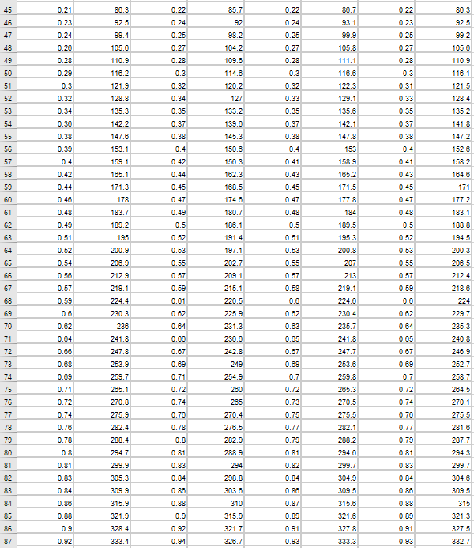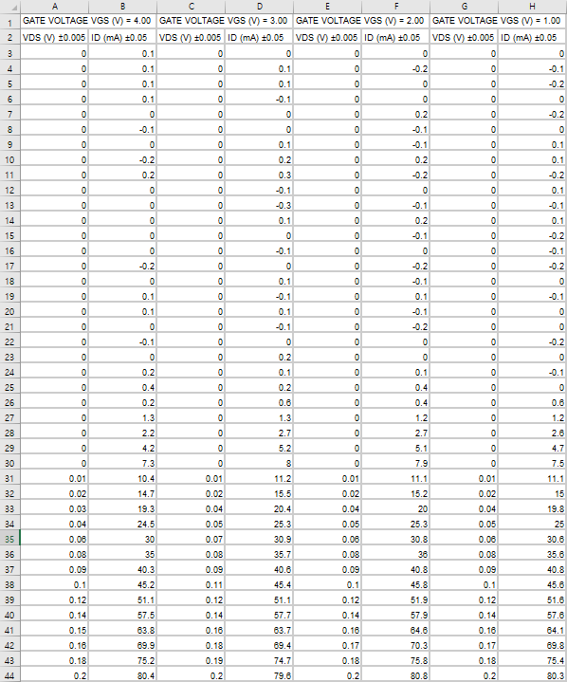

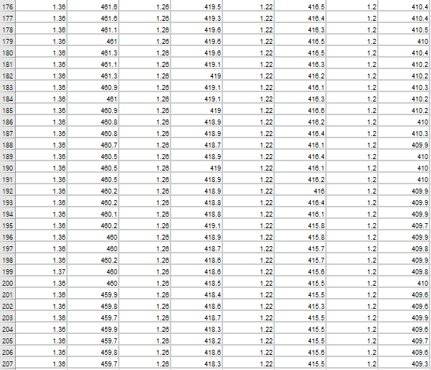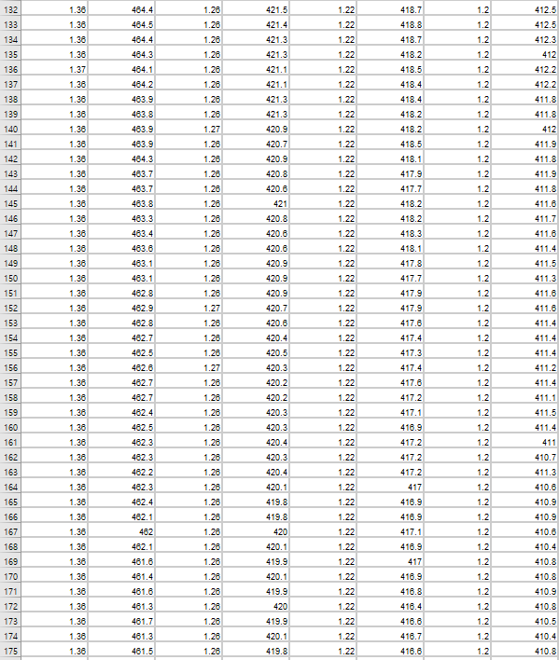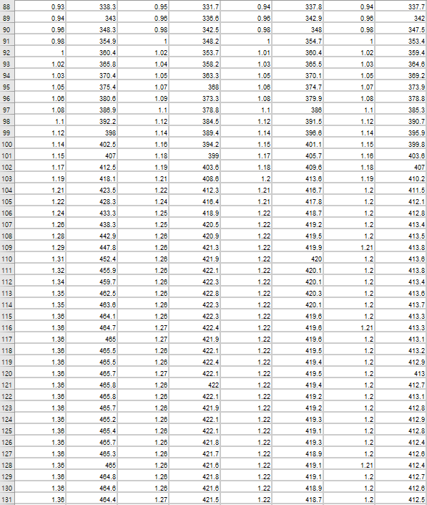

**<Data 2>** VGS and ID for VDS = 5V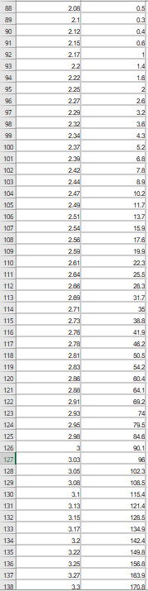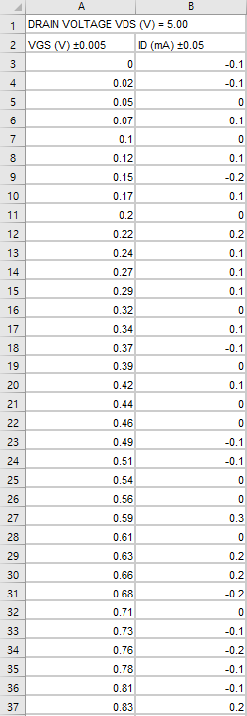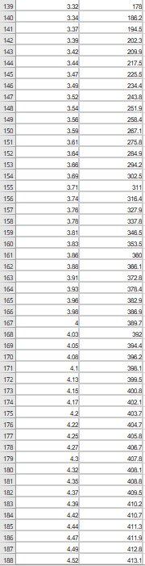

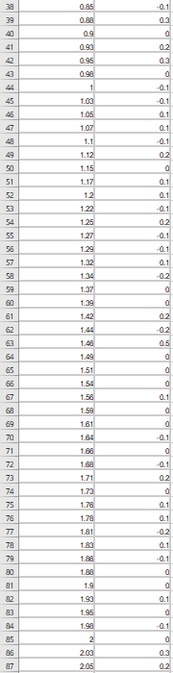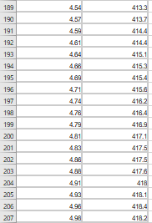

**<Graph 1>** VDS VS ID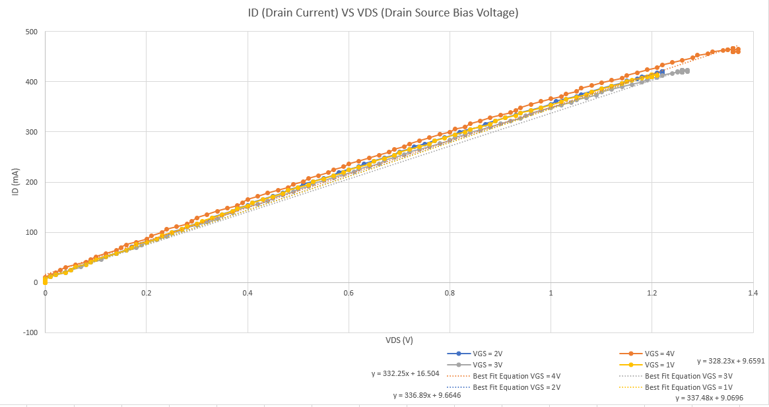

**<Graoh 2>** VGS VS ID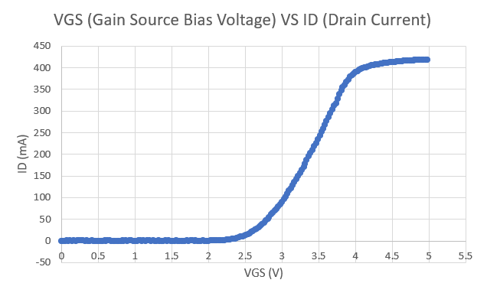

**<Graoh 3>** VGS VS ID Linear Equation

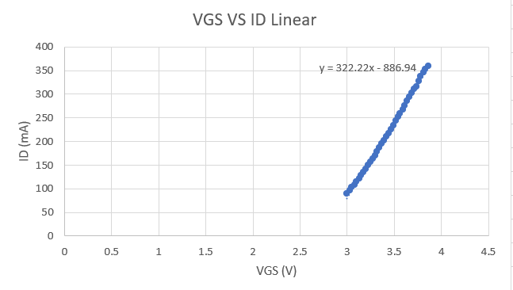

The first graph shows the relationship between Drain Current and Drain Source Bias Voltage. ID and VDS increase proportionally from these two components, which is also shown in the graph. However, once ID reaches a point of saturation, it will no longer increase. From the graph, the saturation point is not easy to determine, but it is roughly around 1.2 Volts from the data we got.

The second graph shows the relationship between Drain Current and Gain Source Bias Voltage with a fixed VDS. In this graph, we can see that the drain current(ID) is only increased if the conditions VGS > VT are met. Making a linear graph for the section of VGS>VT, shows that the VGS and ID increase proportionally. Also, the turn on voltage is around 2.3 Volts.

From the manufacturer specification sheet of 2N700, we can see that the threshold voltage exists in a region between 0.8V to 3V when the drain current is 0.2A (=200mA). According to the second graph, the threshold voltage is around 2.3V which is within the expected range. The typical threshold voltage is 2.1. The calculation of percentage error between the accepted value and the experimental value is below:

$\% Error = \left|\frac{Accepted value - Experimental value}{Accepted Value}\right| ×100\%$

$= \left|\frac{2.1 - 2.3}{2.1}\right| ×100\%$

= 9.524%

From the linear graph of VGS VS ID, the **gfs is 322.22** ms as finding the best-fit equation. From the manufacturer specification sheet, the typical gfs value for 2N7000 and ZVN2106 MOSFET is 320ms and 300ms. The transistor used for this lab was the 2N7000.

The calculation of percentage error between the accepted value and the experimental value is below:

$\% Error = \left|\frac{Accepted value - Experimental value}{Accepted Value}\right| ×100\%$

$= \left|\frac{320 - 322.22}{320}\right| ×100\%$

= 0.694%

“Pulsing” is a process of MOSFET which is directly applied to it. This is applied when the applied continuous drain current (ID) increases by the gate voltage. The turn on voltage is the minimum voltage required to allow the current to flow through, it is dependent on the gate voltage. “Pulsing” is recommended for our measurement because it makes it easy to find the unknown threshold voltage as pulsing is found within the range of no voltage to the turn on voltage.

## Wrap up question

The transconductance gain, or the slope of the graph in the ID vs Vgs is 322.22. According to the manufacturer sheet, the forward transconductance is typically around 320 mS. Since the gain is slightly larger than the one stated on the sheet, the measured results are within the manufacture’s expected range.

Assuming the power demand for the transistor is in the diagram below is 59 W (last two student numbers of Pei) and the voltage supplied is 24 V, the current through the transistor would be 2.458 A (P=Vi). Although the MOSFET could be pulsed to reduce the risk of overheating it, the high power demand and current flowing through the device is likely to ultimately fry it after a short period of time.

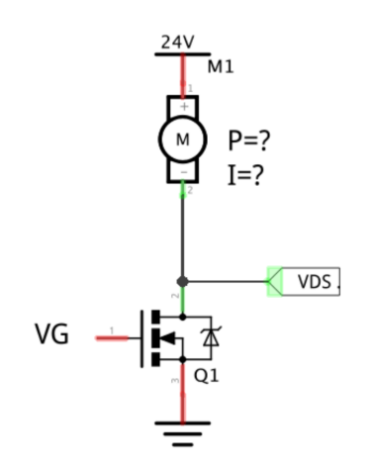

Appendix

**A) Code for Drain-Source voltage vs drain current**

// Call libraries required for external breakout boards and communications.

#include <Wire.h>

#include <SPI.h>

#include <Adafruit_MCP4725.h> // DAC library

#include <Adafruit_INA219.h> // INA219 current sensor library

// Declare a current sensor object.

Adafruit_INA219 ina219; // Commands like ina219.getCurrent_mA() will read the current.

// Declare our voltage supply objects.

Adafruit_MCP4725 dac_vds;

Adafruit_MCP4725 dac_vgs;

#define DAC_RESOLUTION (9) // Set this value to 9, 8, 7, 6 or 5 to adjust the resolution.

// Declare some useful variables.

int stepFunction = 0; // Will allow us to increment VDS or VGS as desired.

void setup(void) {

Serial.begin(9600); // Initiates serial communication, so we can send our data to

// our computer.

// Initialize the INA219 sensor (current sensor).

ina219.begin();

// Initialize our DAC breakout boards.

dac_vds.begin(0x62); // 0x62 sets the hex address of dac_vds

// so the arduino addresses the correct DAC.

dac_vgs.begin(0x63);

}

void loop() {

// dac_vgs.setVoltage(0, false) sets the output voltage to 0V and

// dac_vgs.setVoltage(4095, false) sets the output voltage to 5V.

// Set your desired voltage by selecting a linear range from 0 to 4095.

// Set the voltage to range from 5V to 0V in 0.5V steps.

float VGS = 5; // Fix VGS accordingly

dac_vgs.setVoltage((VGS/5.0)*4095, false);

// Print Gate voltage to serial port.

Serial.print("GATE VOLTAGE VGS (V) = " );

Serial.println(VGS);

// Print table headers to serial port.

Serial.print("VDS");

Serial.print(" ");

Serial.println("ID");

// Sweep VDS from 0 to 5V

for (int i=0; i<4096;i+=20) {

dac_vds.setVoltage(i, false);

delay(5); // Delay for 5ms to stabilize circuit.

// Read VDS and ID at/across the transistor.

Serial.print(ina219.getBusVoltage_V());

Serial.print(" ");

Serial.println(ina219.getCurrent_mA());

dac_vds.setVoltage(0, false); // Set VDS to 0V to allow cooling.

delay(10); // Delay 10ms to allow MOSFET to cool.

}

}

**B) Code for gate voltage vs drain current**

// Call libraries required for external breakout boards and communications.

#include <Wire.h>

#include <SPI.h>

#include <Adafruit_MCP4725.h> // DAC library

#include <Adafruit_INA219.h> // INA219 current sensor library

// Declare a current sensor object.

Adafruit_INA219 ina219; // Commands like ina219.getCurrent_mA() will read the current.

// Declare our voltage supply objects.

Adafruit_MCP4725 dac_vds;

Adafruit_MCP4725 dac_vgs;

#define DAC_RESOLUTION (9) // Set this value to 9, 8, 7, 6 or 5 to adjust the resolution.

// Declare some useful variables.

int stepFunction = 0; // Will allow us to increment VDS or VGS as desired.

void setup(void) {

Serial.begin(9600); // Initiates serial communication, so we can send our data to

// our computer.

// Initialize the INA219 sensor (current sensor).

ina219.begin();

// Initialize our DAC breakout boards.

dac_vds.begin(0x62); // 0x62 sets the hex address of dac_vds

// so the arduino addresses the correct DAC.

dac_vgs.begin(0x63);

}

void loop() {

// Set the Gate voltage, VDS.

// dac_vds.setVoltage(0, false) sets the output voltage to 0V and

// dac_vds.setVoltage(4095, false) sets the output voltage to 5V.

// Set your desired voltage by selecting a linear range from 0 to 4095.

// Set the voltage to range from 5V to 0V in 0.5V steps.

float VDS = 1; // Fix VDS voltage at 5V. To adjust to 4.5V, change variable here and

// re-upload program.

dac_vds.setVoltage((VDS/5.0)*4095, false);

// Print Gate voltage to serial port.

Serial.print("GATE VOLTAGE VDS (V) = " );

Serial.println(VDS);

// Print table headers to serial port.

Serial.print("VGS");

Serial.print(" ");

Serial.println("ID");

// Sweep VGS from 0 to 5V

for (int i=0; i<4096;i+=20) {

dac_vgs.setVoltage(i, false);

delay(5); // Delay for 5ms to stabilize circuit.

// Read VGS and ID at/across the transistor.

Serial.print(ina219.getBusVoltage_V());

Serial.print(" ");

Serial.println(ina219.getCurrent_mA());

dac_vgs.setVoltage(0, false); // Set VGS to 0V to allow cooling.

delay(10); // Delay 10ms to allow MOSFET to cool.

}

}

**C) 2N7000, 2N7002, NDS7002A Maximum Ratings:**

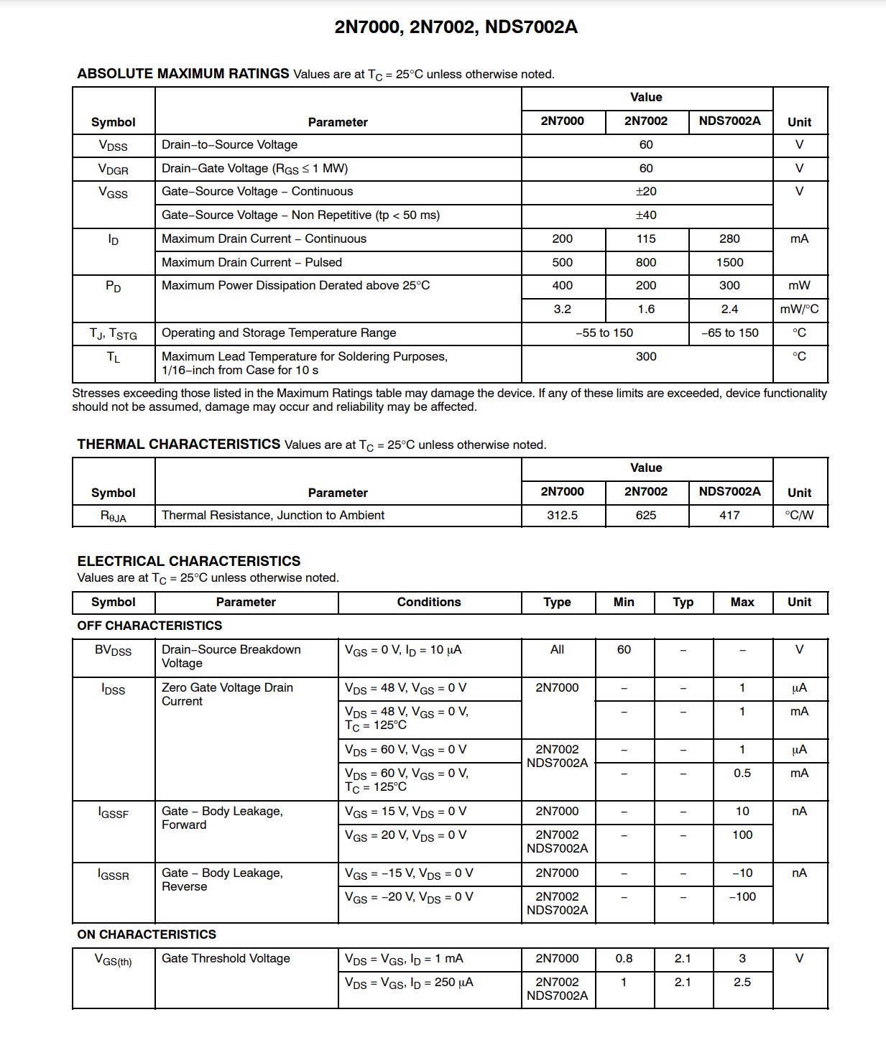

References:

Physics for Scientists and Engineers with Modern Physics”, by Raymond A. Serway and Jewett, Jr., 10th edition, Thomson, Inc.

Data sheet

[**lab 5 pcs 224.xlsx**](https://ryersonprod-my.sharepoint.com/:x:/g/personal/sarah_rhim_ryerson_ca/EbVVv9WAV7hNlRIxVymOhQIBKQDA4crL4hfdCiUqua-CkA?e=av0YhF)

(2022) *N-Channel Enhancement Mode Field Effect Transistor 2N7000, 2N7002, NDS7002A* <https://www.onsemi.com/pdf/datasheet/nds7002a-d.pdf>. Semiconductor Components Industries.